30th Legislative District Republican Party Chairman’s Newsletter
September 2022

Dear Fellow 30th LD Republican Patriots,

I hope you are all enjoying these last days of summer. I appreciate your patience as I was not successful in publishing a newsletter the last couple of months. Nearly two years of planning and working toward major indoor and outdoor home renovations is coming together all at the same time. This is both exciting and overwhelming when one is a do-it-yourself-er!

Thank you so much to all who attended the August General Meeting. In the aftermath of the Primary election, the group was smaller than usual. I am looking forward to a re-energized meeting with a great turnout on September 8. We will hear from speakers who will equip us with very useful information as we prepare to seriously engage in getting our candidates over the finish line in the November 8th Midterm election. Although Linda Kochmar, Casey Jones, and Ashli Tagoai all made it through the Primary, a huge call to arms is needed to close the gap between our wonderful candidates and their Democratic competitors. It will take all of us hitting ground running to help them pull ahead to victory!

How did things go for you before the Primary election?
- Were you able to canvass your precinct?
- Have you been able to use the Campaign SideKick app?
- Have you tried phone calling using the Campaign SideKick app?

Collin Sutrick, our WA State GOP Field Representative, will be one of our speakers at next week’s meeting. He will be presenting information about Campaign SideKick,and will be available to answer your questions.

Judy Fenton from the Family Policy Institute of Washington (FPIW) will also be speaking. She will share practical ways to outreach the churches in our community in an effort to educate congregants about current issues of concern, and to get out the vote.

Please review the following lists of ways to be involved and of upcoming events. Links are provided for your convenience. Reach out if you have questions or concerns. Your feedback regarding the newsletter format and content is welcomed. You are invited to send recommendations for resources and events that might be appropriate to include in next month’s newsletter. In the meantime, please post these items on our facebook page in order to push out the information.

It is an honor to serve as your chairman. I hope you all have a great Labor Day weekend!

With Appreciation,
Terry

Terry Arnold
Chairman, 30th LD Republicans
360-771-5327

Action Items

- Contributions
Link to the secure site for online donations to the 30th LD Republicans: https://secure.anedot.com/30th-districtrepublicans/donate?fbclid=IwAR0dXiPwwL8P7RNlg9UwcUZOFFHSteONs9BQXXopnsz53BtFWEP5I50S7QA

Your donation will go toward providing voter information to the community and promoting candidates who share our values.

- Precinct Committee Officers Recruitment Desperately Needed!
Did you know:
- There are 165 Precincts in the 30th Legislative District.
- 40 Precincts were reached during canvassing before the Primary
- There are 38 PCOs in the 30th LD, leaving 127 open seats.
A list of open seats is available at https://kcgop.org/open-precincts/
Downloadable District Maps can be found at https://kingcounty.gov/depts/elections/elections/maps.aspx
If you know of anyone who, like so many others, is awake, wants to make a difference, but isn’t sure about how to get involved, direct them to https://kcgop.org/pcosignup/ for information about being a PCO, and to sign up. You, or the interested party, can also contact Chairman Terry at (360)771-5327, or chair30thwagop@gmail.com

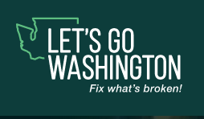

- Go to restorewashington.org. to request your very own FREE packet of the 11 Initiatives, which are part of the 11 Initiatives to the Legislature Project. There is a great list of FAQ on Letsgowashington.com

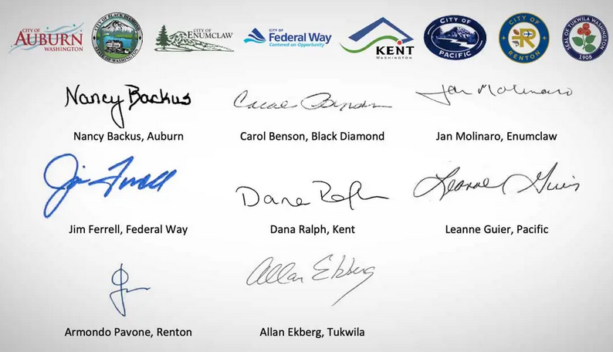

- Read the full letter written by the Mayors of Federal Way, Auburn, Pacific, and five more South King County cities, which states that’s our sharp rise in crime coincides with changes in public safety laws at the state level. https://www.kentwa.gov/.../showp.../19066/637952206875014851
Our young individuals are dying on the street, while our community spaces, including small businesses and parks are being destroyed. Rape and violent crime plague our neighborhoods too. We must repeal and replace these laws for the sake of our community. I look forward to working with these leaders to get this done.

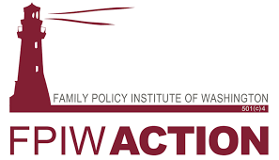

- The Family Policy Institute of WA has kits available that include everything needed to get your church set up to sign initiatives and get out the vote!! Materials are available at no charge for churches and other organizations. Donations are gratefully accepted.
https://ivoterguide.com/church-outreach

Call Judy at FPIW at (425) 608-0242
Judy@fpiw.org

Campaign Sidekick is the app we are using for voter contact.
Weekly trainings are now available via Zoom on Fridays at 6PM and 8PM. During these trainings, attendees will be shown how to use the app for door-to-door canvassing, how to use the app for phone banking, and will be provided with general tips on talking with and listening to voters. There will be Q&A time at the end.
To sign up for a training, please use this link: https://forms.gle/6YewS1EuyynymSCh8
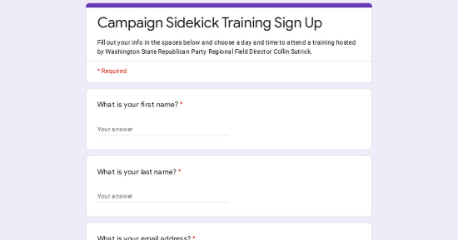 | Campaign Sidekick Training Sign Up  Fill out your info in the spaces below and choose a day and time to attend a training hosted by Washington State Republican Party Regional Field Director Collin Sutrick.  forms.gle

Collin Sutrick, our WA State GOP Regional Field Director, will be speaking with us about Campaign Sidekick during our general meeting on 09/08.

He can provide additional training on how to create walk lists in the Campaign Sidekick system for volunteers. If you don’t want to have to worry about learning how to make walk lists yourself, he is fine with making them for you as well. To have a walk list made, send Collin your email to collin@wsrp.org Cell 253-508-4102, or text him at 253-508-4102, with the precinct name/number you wish to canvas, as well as which volunteers, staffers, or candidates to assign the walklist to.

Federal Way City Council Meetings are on the 1st and 3rd Tuesdays. Go to www.Cityoffederalway.com for time and how to watch the Meeting. Please consider attending some of these meetings and let your voice be heard!
Federal Way Public Schools Meetings are on the 2nd and 4th Tuesdays. Go to www.FWPS.org for more information.

Upcoming Events

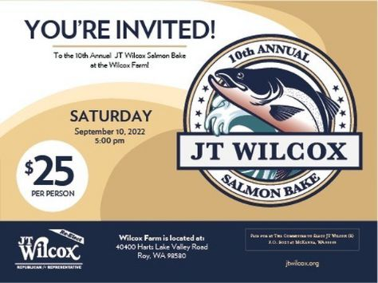
House Republican Leader JT Wilcox, and his family, invite you to come to the Wilcox Family Farms for the 9th Annual Wilcox Salmon Bake.
The Salmon Bake is a family friendly event, and one of the largest of its kind in the state of Washington. Famed for its Washington State inspired menu, a salmon dinner served with Washington wines, local beers, and Puget Sound Oysters.
Kids love the farm setting, old school house and museums.
Adults like the limited speeches and the chance to visit with their state and local elected officials.
Cost is $25 for ages 12-and-up. Ages 11-and-under are free.
Online sales will begin shortly. Event Link
Event Location: Wilcox Farms
Map: 40400 Harts Lake Valley Rd, Roy

6:30. Thursday, 09/15/22
The Church of Blessing,
1430 South 330th Street Federal Way
https://www.churchofblessing.org/

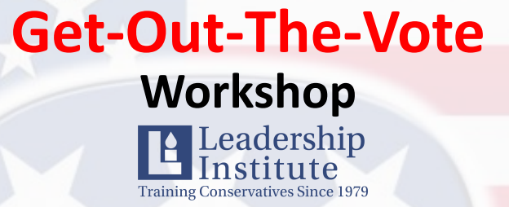

Learn the skills necessary to help you be successful in the Get-Out-The-Vote process. Ideal for conservatives, volunteers, PCO’s, campaign workers and those wishing to make a difference in Washington State.
• Date: Monday September 12, 2022
• Time: 5:30 PM Registration
• 6:00 PM Program Begins
• Location: Bowman Hilton Recreation Center
• 15910 Bowman Hilton Street East, Puyallup, WA 98372
• Cost: $10.00*
• RSVP is required at this link: www.LeadershipInstitute.org/TacomaGOTV
Scholarships are available. Email win2022wa@gmail.com to request.
After you put in your reservation, please email win2022wa@gmail.com for materials for the training.
Cost also includes food to be served at the workshop. Space is limited, so please reserve today.
Thank you for making a difference in 2022!

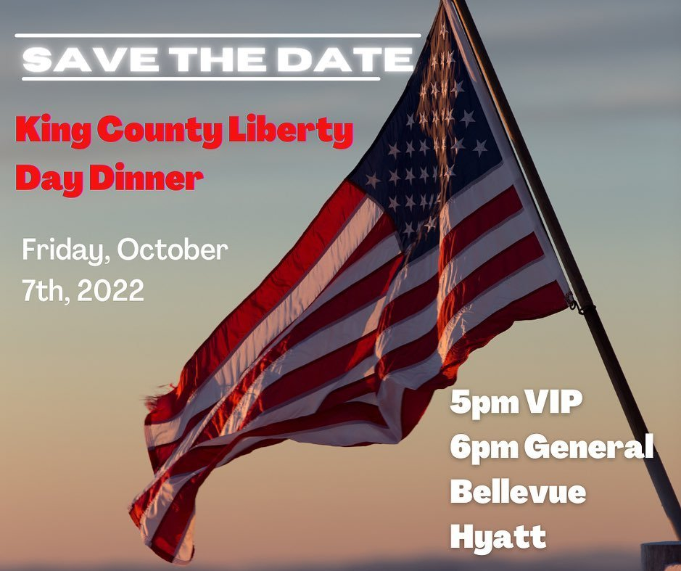
More details forthcoming!

The Liberty Day Dinner speaker will be BRANDON STRAKA, the founder of the #WALKAWAY campaign. Brandon is a FORMER liberal and FORMER Democratic party supporter who has very publicly walked away from the political left and created a social movement encouraging others to do the same!

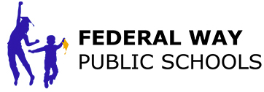
Federal Way School District Board Meeting – September 6 (?) at 6 PM

FWPS meeting will be held in-person at the FWPS Educational Service Center (masks optional as of 3/12/2022) with the option to attend remotely. *Effective 4/15/2022, certain meetings will be held at alternative locations. Please find meeting details on the board meeting agendas located at BoardDocs: https://go.boarddocs.com/wa/fwsd210/Board.nsf/Public

Beginning AUGUST 30th, Project Veritas is set to release a MULTI-PART undercover series exposing The Secret Curriculum in the American Education System that is indoctrinating your children.
Do YOU know what they are teaching YOUR kids?
We can GUARANTEE you that this series will likely be censored like we have never seen before.
To make sure that you are able to SEE and SHARE these stories, sign up for our dedicated video distribution channel at www.TheSecretCurriculum.com
We need YOUR help to ensure parents across the nation see these shocking tapes.
SIGN UP NOW & SHARE: www.TheSecretCurriculum.com
https://secure3.convio.net/pv/site/SPageServer/?pagename=the_secret_curriculum

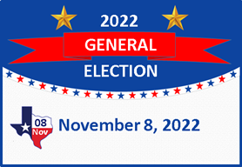

November 8 General Election - Deposit your ballot in an official drop box by 8:00pm on Election Day.

Resources

Family Educational Rights and Privacy Act (FERPA) https://www2.ed.gov/policy/gen/guid/fpco/ferpa/index.html

Gives parents certain rights with respect to their children's education records.
- Parents or eligible students have the right to inspect and review the student's education records maintained by the school.
- Parents or eligible students have the right to request that a school correct records which they believe to be inaccurate or misleading.
- The school isn't going to tell you your child's gender identity. If you have a suspicion that something is going on with your child, request to see their records.
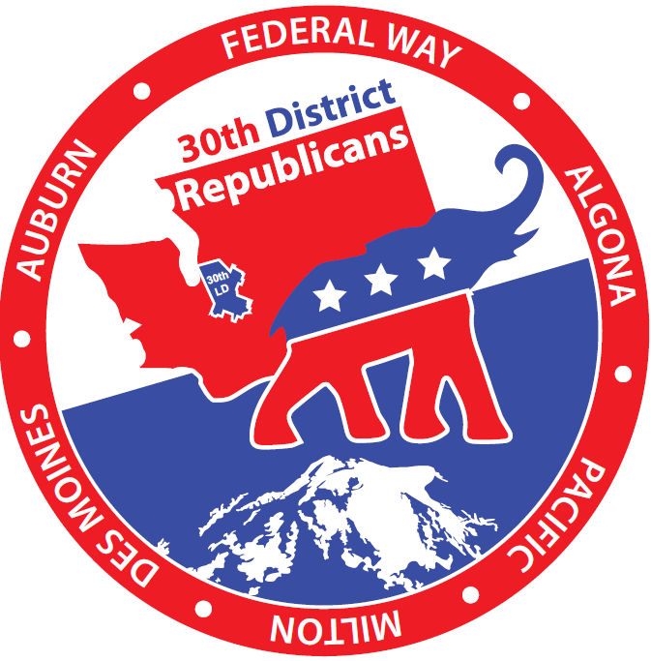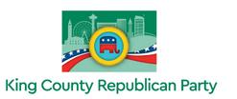
Social Media Contacts:

30th LD Republicans Website: https://www.fwgop.org/

30th LD Republicans Facebook page: https://www.facebook.com/groups/30thLDRepublicans

Twitter https://fwgop.us20.list-manage.com/track/click?u=8af2a3c03cb9ee247cbbabae1&id= 53cf5c6c9f&e=a843a6af23
Instagram https://fwgop.us20.list-manage.com/track/click?u=8af2a3c03cb9ee247cbbabae1&id= eb05e8f521&e=a843a6af23
9th Congressional District Republicans Facebook page: https://www.facebook.com/groups/9thCDRWASTATE/

King County GOP website: https://kcgop.org/

King County Elections 206-296-8683
elections@kingcounty.gov http://www.kingcounty.gov/elections

https://www.notthemirror.com/post/shopping-cart-theft-in-federal-way
Not the Mirror is a website associated with Stand Up Federal Way, dedicated to printing Federal Way news, that for various reasons, is not, or likely will not be, published by the Federal Way Mirror.

